`

Coffee Shop

A PROJECT REPORT

SUBMITTED IN FULFILLMENT OF THE REQUIREMENT FOR THE AWARD OF THE DEGREE OF

Bachelors in Computers Application

To

RK University, RAJKOT

SUBMITTED BY

Name of Student: Enrollment

Kiran Rai 21FOTCA11610

Ram Gurung 21FOTCA11606

Division: A

UNDER THE GUIDANCE OF

Guid Name :

MS. Sakshi jobanputra Dr. Paresh Tan

RK University Professor(HOD)

RAJKOT RK University

RAJKOT



SCHOOL OF ENGINEERING, RK UNIVERSITY,RAJKOT



DECLARATION

We hereby certify that we are the sole authors of this project work and that neither

any part of this project work nor the whole of the project work has been submitted for a

degree to any other University or Institution. We certify that, to the best of our knowledge,

our project work does not infringe upon anyone’s copyright nor violate any proprietary

rights and that any ideas, techniques, quotations, or any other material from the work of

other people included in our project document, published or otherwise, are fully

acknowledged in accordance with the standard referencing practices. We declare that this

is a true copy of our project work, including any final revisions, as approved by our project

review committee.

Project Team

Student Name (Enrollment No)

Kiran Rai 21FOTCA11610

Ram Gurung 21FOTCA11606

Date: -25/3/2024

Place: Rk University(Rajkot)

Table of Contents

|  |  |  |
| --- | --- | --- |
| SI.No | Title | page |
| 1 | ACKNOWLEDGEMENT |  |
| 2 | ABSTRACT |  |
| 3 | INTRODUCTION |  |
| 4 | PROJECT SUMMARY |  |
| 5 | PURPOSE |  |
| 6 | HTML, CSS, PHP |  |
| 7 | PROJECT MANAGEMENT |  |
| 8 | PROJECT PLANNING AND SCHEDULING |  |
| 9 | PROJECT PLAN |  |
| 10 | SCHEDULE REPRESENTATION |  |
| 11 | SYSTEM ANALYSIS |  |
| 12 | STUDY OF CURRENT SYSTEM |  |
| 13 | PROBLEM & WEAKNESS OF CURRENT SYSTEM |  |
| 14 | FEASIBILITY STUDY |  |
| 16 | REQUIREMENT VALIDATION |  |
| 17 | FUNCTION SYSTEM |  |
| 18 | E-R DIAGRAM |  |
| 19 | USE CASE DIAGRAM |  |
| 20 | DATA FLOW DIAGRAM |  |
| 22 | DATA MODELING |  |
| 23 | MAIN MODULES OF NEW SYSTEM |  |
| 24 | DATA DICTIONARY |  |
| 25 | SYSTEM DESIGN |  |
| 26 | FLOW CHART |  |
| 27 | TESTING |  |
| 28 | TEST PLAN |  |
| 29 | TESTING STRATEGY |  |
| 30 | TESTING METHODS |  |
| 31 | TESTING CASES |  |
| 32 | SCREEN SHOTS |  |
| 33 | LIMITATION & FUTURE ENHANCEMENT |  |
| 34 | CONCLUSION AND DISCUSSION |  |
| 35 | REFERENCES |  |

ACKNOWLEDGEMENT

We extend our heartfelt gratitude to all those who have contributed to the realization of this

project. We would like to express our sincere appreciation to our advisors, mentors, and

teachers who have provided us with invaluable guidance and support throughout the journey.

We are also deeply indebted to the senior citizens and their families who trusted us with their

care and well-being. Our project is a collective effort, and it wouldn't have been possible

without the dedication and hard work of our team members and volunteers. Your unwavering

support has been the cornerstone of our mission.

Abstract:

Coffee shops have emerged as iconic cultural spaces globally, reflecting the intricate interplay

of societal dynamics, economic trends, and individual preferences. This paper delves into the

abstract essence of coffee shops, aiming to uncover the multifaceted roles they play in

contemporary society. Through a blend of qualitative and quantitative analyses, we examine

the symbolic significance, social functions, and economic implications of these establishments.

Furthermore, we explore how coffee shops serve as hubs for social interaction, creativity, and

community engagement, transcending their primary function of dispensing caffeinated

beverages. By scrutinizing the abstract dimensions of coffee shop culture, this research

contributes to a deeper understanding of urban lifestyles, consumption patterns, and the

evolving fabric of modern society.

Introduction

Welcome to the exciting world of coffee shop management! This project is centred around the

development of a dynamic web application using PHP that aims to streamline the operations

and enhance the customer experience of a coffee shop. In today's fast-paced world, coffee shops

have become more than just places to grab a quick caffeine fix; they are social hubs, creative

spaces, and community gathering points. Therefore, it's crucial for coffee shop owners to

leverage technology effectively to meet the evolving needs of their patrons.

Through this project, we will explore the essential functionalities of a coffee shop management

system built using PHP. This system will encompass various modules, including order

management, inventory tracking, customer relationship management, and reporting. By

harnessing the power of PHP, we can create a robust and user-friendly platform that empowers

coffee shop owners and staff to operate more efficiently and deliver exceptional service to their

customers

Summary

In summary, this PHP-based coffee shop management project aims to revolutionize the way

coffee shops operate in the digital age. By developing a comprehensive web application, we

seek to streamline processes, improve communication, and enhance the overall customer

experience. From order processing to inventory management to customer engagement, our

system will provide coffee shop owners with the tools they need to succeed in a competitive

market.

Through the implementation of PHP, we can ensure scalability, flexibility, and security in our

application, allowing coffee shop owners to adapt to changing business needs and industry

trends seamlessly. By investing in technology and innovation, we can help coffee shops thrive

and continue to serve as vital community hubs for years to come.

Purpose:

The purpose of your project, BrewTech: Revolutionizing Coffee Shop Management with PHP,

is multifaceted and aims to address several key objectives:

Efficiency Enhancement: The project seeks to streamline and optimize various aspects of

coffee shop management, including order processing, inventory tracking, and customer

relationship management. By developing a comprehensive web application, BrewTech aims to

automate routine tasks, reduce manual errors, and improve overall operational efficiency.

Customer Experience Improvement: BrewTech endeavours to enhance the customer

experience within coffee shops by providing intuitive ordering interfaces, personalized

services, and efficient transaction processing. By capturing and analysing customer data, the

system can identify preferences, anticipate needs, and tailor recommendations, thereby

fostering greater satisfaction and loyalty.

Business Growth Facilitation: Through advanced reporting and analytics capabilities,

BrewTech aims to provide coffee shop owners with valuable insights into sales trends,

inventory performance, and customer behavior. Armed with this information, owners can make

informed decisions, identify growth opportunities, and optimize their business strategies to

drive profitability and expansion.

Technology Empowerment: By leveraging the power of PHP and modern web development

frameworks, BrewTech aims to empower coffee shop owners and staff with user-friendly tools

and interfaces. The project provides training, support, and ongoing maintenance to ensure that

users can harness the full potential of the system and adapt to evolving business needs.

Competitive Advantage: Ultimately, the purpose of BrewTech is to equip coffee shop owners

with a competitive edge in the market. By offering a comprehensive and innovative solution

for coffee shop management, BrewTech enables owners to differentiate their businesses, attract

more customers, and thrive in an increasingly competitive industry landscape.

Overall, the purpose of BrewTech is to revolutionize coffee shop management by harnessing

the capabilities of PHP and technology to enhance efficiency, improve customer experiences,

facilitate business growth, empower users, and gain a competitive advantage in the market.

HTML, CSS, PHP

BrewTech is an innovative project that leverages HTML, PHP, JavaScript, CSS, and other web

technologies to revolutionize coffee shop management. By integrating these languages and

frameworks, BrewTech aims to address various challenges faced by coffee shop owners and

streamline their operations for improved efficiency and customer satisfaction.

Using HTML for markup, BrewTech creates the structure of dynamic web pages, ensuring

clarity and accessibility for users across different devices. PHP serves as the backbone of the

project, enabling server-side processing and database interactions to handle critical

functionalities such as order management, inventory tracking, and customer relationship

management.

JavaScript enhances the user experience by adding interactivity and dynamic content to

BrewTech's web interface. From validating form inputs to updating information in real-time,

JavaScript plays a crucial role in making the application more responsive and user-friendly.

CSS is utilized to style BrewTech's interface, ensuring consistency, branding, and visual

appeal. By applying CSS principles such as layout design, color schemes, and typography,

BrewTech achieves a polished and professional look that enhances usability and reinforces

brand identity.

In summary, BrewTech harnesses the power of HTML, PHP, JavaScript, and CSS to create a

comprehensive coffee shop management system. By combining these languages and

technologies, BrewTech offers coffee shop owners a powerful tool to optimize their operations,

improve customer experiences, and stay competitive in the rapidly evolving hospitality industry.

 PROJECT MANAGEMENT

Project Management Plan: BrewTech Coffee Shop Management System

Project Overview:

Project Name: BrewTech Coffee Shop Management System

Project Objective: Develop a web-based application using HTML, PHP, JavaScript, and CSS

to streamline coffee shop operations, enhance customer experiences, and empower coffee shop

owners and staff.

Project Duration: [Insert Start Date] to [Insert End Date]

Project Manager: [Insert Project Manager Name]

Project Team: [Insert Team Members and Roles]

Scope Management:

Scope Statement: The project includes the development of a comprehensive coffee shop

management system encompassing order management, inventory tracking, customer

relationship management, reporting, and user management functionalities.

Scope Verification: Regular meetings with stakeholders to review project progress and ensure

alignment with project objectives.

Scope Control: Any changes to the project scope will be evaluated for their impact on schedule,

budget, and resource allocation. Changes must be approved by the project manager and

stakeholders before implementation.

Schedule Management:

Work Breakdown Structure (WBS): Break down project tasks into smaller, manageable

components.

Gantt Chart: Develop a Gantt chart to visualize project tasks, dependencies, and timelines.

Critical Path Analysis: Identify critical tasks and allocate resources accordingly to ensure

project milestones are met.

Schedule Control: Regular monitoring of project progress against the schedule, with

adjustments made as necessary to mitigate delays or resource constraints.

Cost Management:

Budget Allocation: Allocate resources (personnel, software, hardware, etc.) based on project

requirements and available budget.

Cost Tracking: Monitor project expenses and track against the allocated budget.

Cost Control: Implement measures to control costs, such as optimizing resource utilization,

negotiating vendor contracts, and minimizing scope creep.

Quality Management:

Quality Standards: Define quality standards and criteria for project deliverables.

Quality Assurance: Conduct regular reviews and inspections to ensure compliance with quality

standards.

Quality Control: Implement testing procedures to identify and address defects or deviations

from requirements.

Risk Management:

Risk Identification: Identify potential risks and uncertainties that may impact project

objectives.

Risk Assessment: Evaluate the likelihood and potential impact of identified risks.

Risk Mitigation: Develop strategies to mitigate or minimize risks, such as contingency plans,

risk transfer, or risk avoidance.

Risk Monitoring: Continuously monitor project risks and implement proactive measures to

address emerging threats.

Communication Management:

Stakeholder Communication: Establish regular communication channels with stakeholders to

provide updates on project progress, address concerns, and solicit feedback.

Team Communication: Foster open communication within the project team to facilitate

collaboration, problem-solving, and knowledge sharing.

Documentation: Maintain comprehensive documentation of project plans, requirements,

decisions, and progress reports.

Procurement Management:

Vendor Selection: Identify and select vendors for any external resources or services required

for the project.

Contract Negotiation: Negotiate contracts with vendors to ensure favorable terms and

conditions.

Vendor Management: Monitor vendor performance and ensure adherence to contractual

agreements.

Change Management:

Change Control Process: Establish a formal process for requesting, evaluating, and

implementing changes to project scope, schedule, or requirements.

Change Impact Analysis: Assess the impact of proposed changes on project objectives,

timeline, and resources.

Change Implementation: Implement approved changes in a controlled manner, ensuring proper

communication and documentation.

Project Closure:

Final Review: Conduct a comprehensive review of project deliverables against initial

requirements and objectives.

Lessons Learned: Document lessons learned from the project, including successes, challenges,

and areas for improvement.

Project Handover: Transfer project deliverables, documentation, and knowledge to relevant

stakeholders or support teams.

Closure Report: Prepare a final project closure report summarizing project outcomes,

achievements, and recommendations for future projects.

This Project Management Plan outlines the key components and strategies for successfully

managing the BrewTech Coffee Shop Management System project. Adherence to these

management practices will ensure efficient project execution, stakeholder satisfaction, and

successful delivery of project objectives.

  Project Planning and Scheduling

Project Planning and Scheduling for BrewTech Coffee Shop Management System

Project Definition:

Objective: Develop a comprehensive web-based coffee shop management system to streamline

operations, enhance customer experiences, and empower coffee shop owners and staff.

Scope: The project will include the development of modules for order management, inventory

tracking, customer relationship management, reporting, and user management.

Project Deliverables:

Detailed project plan outlining tasks, timelines, and responsibilities.

Fully functional web application for coffee shop management.

Documentation including user manuals, technical specifications, and training materials.

Implementation of quality assurance processes to ensure system reliability and performance.

Project Team:

Project Manager: [Name]

Developers: [List]

Designers: [List]

Quality Assurance: [List]

Stakeholders: [List]

Project Planning:

Define Project Scope: Clearly outline the functionalities and features of the coffee shop

management system.

Identify Resources: Determine human resources, equipment, software, and other resources

required for project execution.

Risk Assessment: Identify potential risks and develop strategies to mitigate or manage them.

Communication Plan: Establish communication channels and protocols for stakeholders, team

members, and external vendors.

Project Scheduling:

Work Breakdown Structure (WBS): Break down the project into smaller, manageable tasks.

Task Dependencies: Identify dependencies between tasks to establish the sequence of work.

Estimate Task Durations: Estimate the time required to complete each task based on resource

availability and complexity.

Gantt Chart: Develop a Gantt chart to visualize task timelines, dependencies, and milestones.

Critical Path Analysis: Identify the critical path and allocate resources accordingly to ensure

timely completion of critical tasks.

Resource Allocation:

Allocate human resources based on skill sets, availability, and project requirements.

Procure necessary equipment, software licenses, and other resources as per project needs.

Ensure adequate budget allocation for resource procurement and project execution.

Quality Assurance:

Define quality standards and criteria for project deliverables.

Implement testing processes to verify system functionality, usability, and performance.

Conduct regular quality assurance checks throughout the project lifecycle to maintain quality

standards.

Risk Management:

Continuously monitor project risks and implement risk mitigation strategies as needed.

Review and update the risk register regularly to address emerging risks and changing

circumstances.

Communicate risk status and mitigation plans to stakeholders to ensure transparency and

accountability.

Project Monitoring and Control:

Establish key performance indicators (KPIs) to measure project progress and performance.

Conduct regular project status meetings to review progress, identify issues, and make necessary

adjustments.

Implement change control processes to manage scope changes and minimize project

disruptions.

Project Closure:

Conduct a final project review to assess deliverables against project objectives and

requirements.

Document lessons learned and best practices for future reference.

Obtain sign-off from stakeholders and formally close the project.

By following this project planning and scheduling framework, we aim to ensure the successful

execution of the BrewTech Coffee Shop Management System project, delivering a high-quality

solution that meets stakeholder expectations and contributes to the success of coffee shop

owners and staff.

System analysis

Study of current system

Study of Current System: BrewTech Coffee Shop Operations

Overview:

BrewTech is currently operating with a manual system for managing its coffee shop operations.

This involves a combination of paper-based processes, manual order taking, and limited use of

basic software tools for inventory management and customer tracking.

Order Management:

Currently, orders are primarily taken manually by staff using pen and paper or through a basic

POS (Point of Sale) system. This process is prone to errors, delays, and inefficiencies,

especially during peak hours.

There is no centralized system for order processing, leading to challenges in tracking orders,

managing inventory levels, and ensuring timely service.

Inventory Management:

Inventory management is largely manual, with inventory levels tracked using spreadsheets or

basic inventory management software.

Stock replenishment and reordering are typically done based on manual observation or periodic

inventory checks, leading to stockouts or overstock situations.

Customer Relationship Management (CRM):

Customer information is collected manually through paper-based loyalty cards or basic CRM

tools. However, there is limited integration between customer data and order history, making

it challenging to personalize services or analyze customer preferences.

Feedback collection is sporadic, often relying on manual comment cards or verbal feedback,

which may not capture a comprehensive view of customer satisfaction.

Reporting and Analytics:

Reporting and analytics capabilities are minimal, with limited insights into sales trends, popular

items, or profitability.

Analysis of business performance relies mainly on manual data compilation and basic reporting

tools, resulting in limited visibility into key performance indicators.

Challenges:

The current manual system is prone to errors, inconsistencies, and inefficiencies, leading to

delays in service, inventory discrepancies, and missed business opportunities.

Lack of integration between different operational areas (order management, inventory, CRM)

hampers efficiency and limits the ability to provide personalized customer experiences.

Limited reporting and analytics capabilities hinder data-driven decision-making and strategic

planning.

Opportunities for Improvement:

Implementing a comprehensive coffee shop management system will streamline operations,

improve efficiency, and enhance customer experiences.

Automation of order processing, inventory management, and CRM functions will reduce

errors, optimize resource utilization, and enable personalized services.

Enhanced reporting and analytics capabilities will provide actionable insights for informed

decision-making and strategic growth.

Conclusion:

The study of the current system highlights the need for modernization and optimization of

BrewTech's coffee shop operations. By transitioning from manual processes to a

comprehensive web-based management system, BrewTech can overcome existing challenges,

unlock new opportunities, and position itself for long-term success in the competitive coffee

shop industry.

Problems and weakness of current system

Problems and Weaknesses of the Current System at BrewTech Coffee Shop

Manual Order Processing:

The current system relies heavily on manual order processing methods, such as handwritten

tickets or basic POS systems. This manual approach leads to errors in order taking, delays in

service, and inefficiencies during peak hours.

Staff may struggle to keep track of multiple orders simultaneously, resulting in confusion and

longer wait times for customers.

Limited Inventory Management:

Inventory management is primarily conducted manually, with inventory levels tracked using

spreadsheets or basic software tools. This manual approach is prone to errors and

inconsistencies, leading to stockouts or overstock situations.

Lack of real-time inventory tracking makes it challenging to accurately monitor stock levels

and anticipate reordering needs, resulting in potential loss of sales or wastage.

Inefficient Customer Relationship Management (CRM):

The current CRM system, if any, is rudimentary and lacks integration with other operational

areas. Customer information may be collected through paper-based methods or basic CRM

software, but there is limited utilization of this data for personalized services or targeted

marketing.

Feedback collection is sporadic, and there is a lack of systematic mechanisms for gathering and

analyzing customer feedback, leading to missed opportunities for improving customer

satisfaction and loyalty.

Limited Reporting and Analytics:

Reporting and analytics capabilities are minimal, with limited visibility into key performance

indicators such as sales trends, popular items, or profitability.

Manual data compilation and basic reporting tools make it challenging to extract actionable

insights from business data, hindering informed decision-making and strategic planning.

Operational Inefficiencies:

Overall, the manual nature of the current system results in operational inefficiencies, including

increased labor costs, higher error rates, and slower service delivery.

Lack of integration between different operational areas leads to disjointed processes and missed

opportunities for optimization and improvement.

Scalability and Growth Limitations:

The current system may struggle to accommodate the growing demands of BrewTech's

business as it expands. Manual processes and limited technological capabilities may hinder

scalability and inhibit the ability to capitalize on new opportunities for growth.

Customer Experience Impact:

Ultimately, the problems and weaknesses of the current system directly impact the customer

experience at BrewTech. Longer wait times, order errors, and inconsistent service can lead to

decreased customer satisfaction, reduced loyalty, and negative word-of-mouth.

Addressing these problems and weaknesses through the implementation of a modern,

integrated coffee shop management system will be critical for BrewTech to improve

operational efficiency, enhance customer experiences, and position itself for sustainable

growth and success in the competitive coffee shop industry.

**Feasibility studies**

Feasibility Studies for Implementing a Coffee Shop Management System at BrewTech

Technical Feasibility:

Hardware Requirements: Assess the hardware infrastructure available at BrewTech, including

servers, computers, POS systems, and networking equipment, to determine if they meet the

technical requirements for implementing the coffee shop management system.

Software Compatibility: Evaluate the compatibility of existing software systems and

applications with the proposed management system. Ensure that the new system can integrate

seamlessly with other tools used by BrewTech for accounting, payroll, and customer

communication.

Technology Stack: Determine the feasibility of using HTML, PHP, JavaScript, and CSS for

system development based on the availability of expertise, support, and resources.

Operational Feasibility:

User Acceptance: Assess the readiness of BrewTech's staff to adapt to the new coffee shop

management system. Conduct training sessions and provide support to ensure smooth transition

and user acceptance.

Process Integration: Evaluate how the new system will integrate with existing operational

processes at BrewTech. Identify any potential bottlenecks or challenges in implementing the

system and develop strategies to address them.

Scalability: Determine if the proposed system can accommodate the current and future needs

of BrewTech as it grows and expands its operations. Assess the scalability of the system

architecture, database design, and user interface to ensure long-term viability.

Financial Feasibility:

Cost-Benefit Analysis: Conduct a cost-benefit analysis to evaluate the financial feasibility of

implementing the coffee shop management system. Estimate the initial investment required for

system development, hardware and software procurement, training, and ongoing maintenance.

Compare these costs with the anticipated benefits, including increased efficiency, cost savings,

and revenue growth.

Return on Investment (ROI): Calculate the projected ROI of the coffee shop management

system over a specified period, taking into account factors such as increased sales, reduced

labour costs, and improved customer satisfaction. Assess the payback period and net present

value (NPV) to determine the financial viability of the investment.

Budget Allocation: Develop a detailed budget plan for implementing the system, including

allocation of funds for development, hardware/software procurement, training, and

contingency. Ensure that the project remains within budget constraints and aligns with

BrewTech's financial goals and priorities.

Legal and Regulatory Feasibility:

Compliance Requirements: Identify and assess any legal and regulatory requirements that may

impact the implementation of the coffee shop management system, such as data protection

laws, food safety regulations, and consumer rights legislation.

Privacy and Security: Ensure that the system design and implementation comply with industry

standards and best practices for data privacy and security. Implement measures to safeguard

customer information, payment data, and sensitive business data against unauthorized access,

breaches, or misuse.

Intellectual Property Rights: Review existing agreements, licenses, and contracts to ensure that

the development and implementation of the coffee shop management system do not infringe

upon any third-party intellectual property rights or proprietary information.

Environmental Feasibility:

Sustainability Considerations: Evaluate the environmental impact of implementing the coffee

shop management system, including energy consumption, waste generation, and carbon

footprint. Identify opportunities to minimize environmental impact through energy-efficient

hardware/software choices, paperless operations, and waste reduction strategies.

Green Practices: Incorporate sustainable practices into system design and operation, such as

using eco-friendly materials, optimizing energy usage, and promoting recycling and reuse

initiatives. Align the implementation of the system with BrewTech's commitment to

environmental stewardship and corporate social responsibility.

Requirement Validation

Requirement Validation for BrewTech Coffee Shop Management System

Stakeholder Involvement:

Engage key stakeholders, including coffee shop owners, managers, staff, and customers, in the

requirement validation process.

Conduct stakeholder interviews, surveys, or workshops to gather feedback, insights, and

requirements for the coffee shop management system.

Documentation Review:

Review existing documentation, such as business requirements, user stories, and functional

specifications, to ensure completeness and accuracy.

Verify that all identified requirements align with business objectives, user needs, and

regulatory/compliance standards.

Prototyping and Mock-ups:

Develop prototypes or mock-ups of the coffee shop management system's user interface to

visualize and validate user interactions, workflows, and screen designs.

Solicit feedback from stakeholders on the prototypes to identify any discrepancies or gaps in

the requirements.

User Acceptance Testing (UAT):

Conduct user acceptance testing sessions with representatives from different user groups to

validate system functionality, usability, and performance.

Allow users to interact with the system in a simulated environment and provide feedback on

their experiences, preferences, and any issues encountered.

Requirement Traceability:

Establish traceability between requirements and system design elements, such as use cases,

features, and test cases, to ensure that all requirements are addressed and validated.

Use requirement management tools or traceability matrices to track the status of each

requirement throughout the development lifecycle.

Validation Criteria:

Define clear validation criteria for each requirement, including measurable objectives,

acceptance criteria, and success metrics.

Verify that the system meets the defined criteria for functionality, performance, reliability,

security, and user experience.

Cross-Functional Review:

Involve cross-functional teams, such as development, quality assurance, and operations, in

requirement validation activities to gain diverse perspectives and insights.

Conduct peer reviews and walkthroughs of requirements documents and system specifications

to identify any inconsistencies, ambiguities, or conflicts.

Regulatory Compliance:

Validate that the coffee shop management system complies with relevant regulatory

requirements, industry standards, and best practices.

Conduct compliance checks against applicable laws, regulations, and industry guidelines

related to data privacy, security, payment processing, and food safety.

Feedback Incorporation:

Gather feedback from stakeholders and users throughout the requirement validation process

and incorporate it into the system design and development.

Prioritize and address any identified issues, concerns, or enhancement requests to ensure that

the final system meets stakeholder expectations and requirements.

**Function System**

**E-R Diagram**

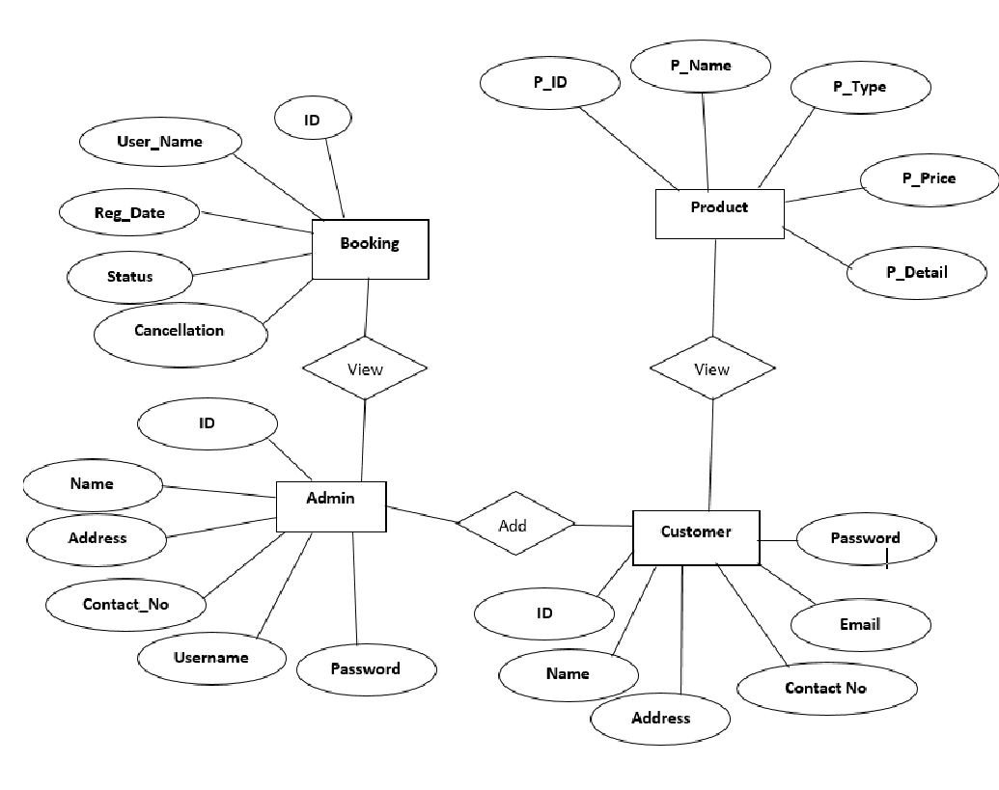

Fig: amdssubr

**Use case Diagram**

**Use case Diagram for Admin:**

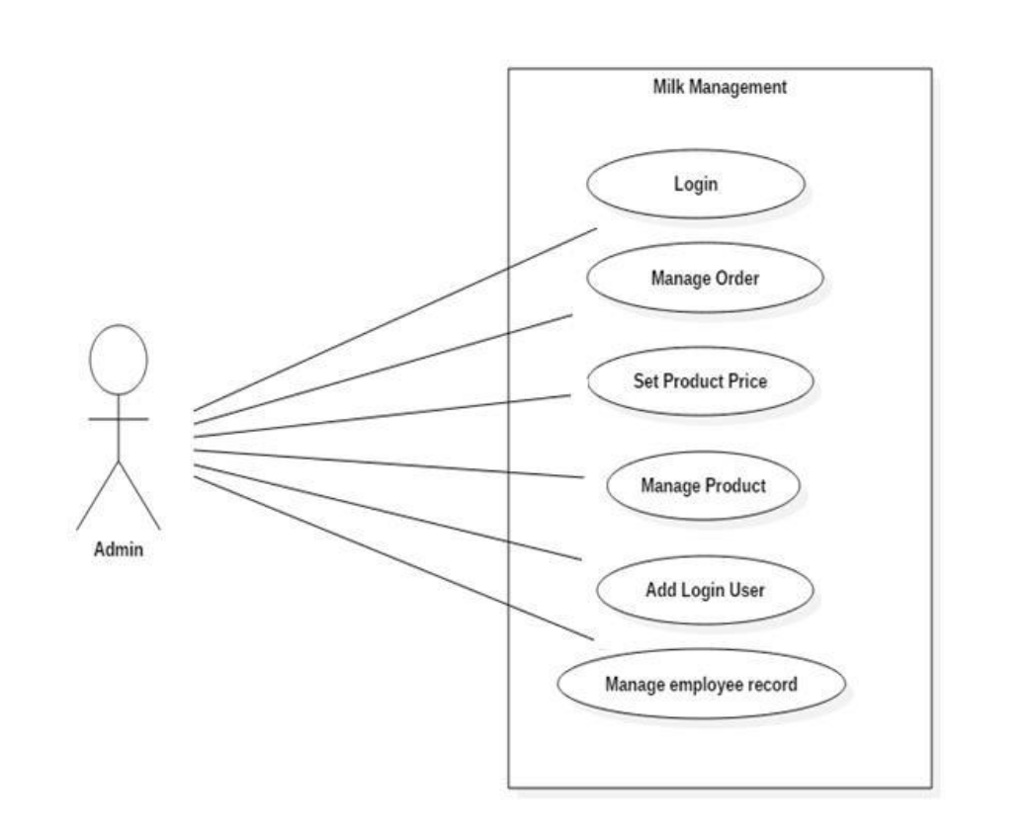

use case diagram for Customer:

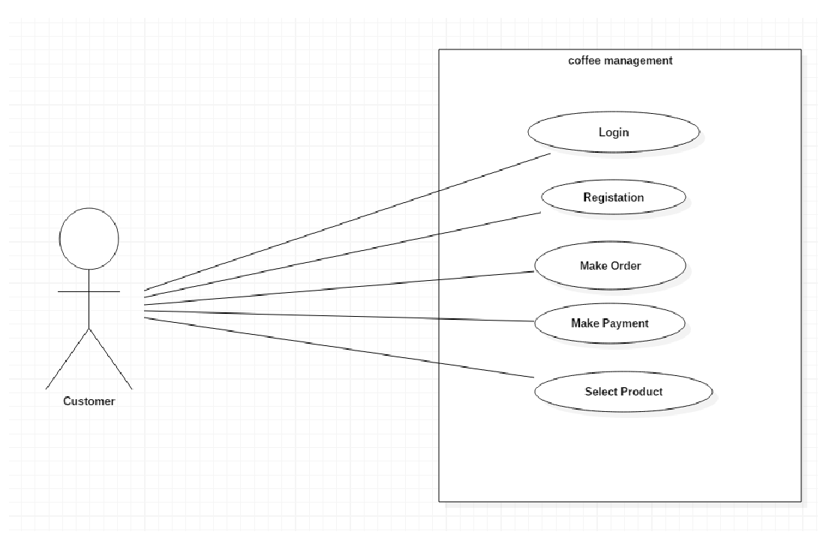

Data Dictionary

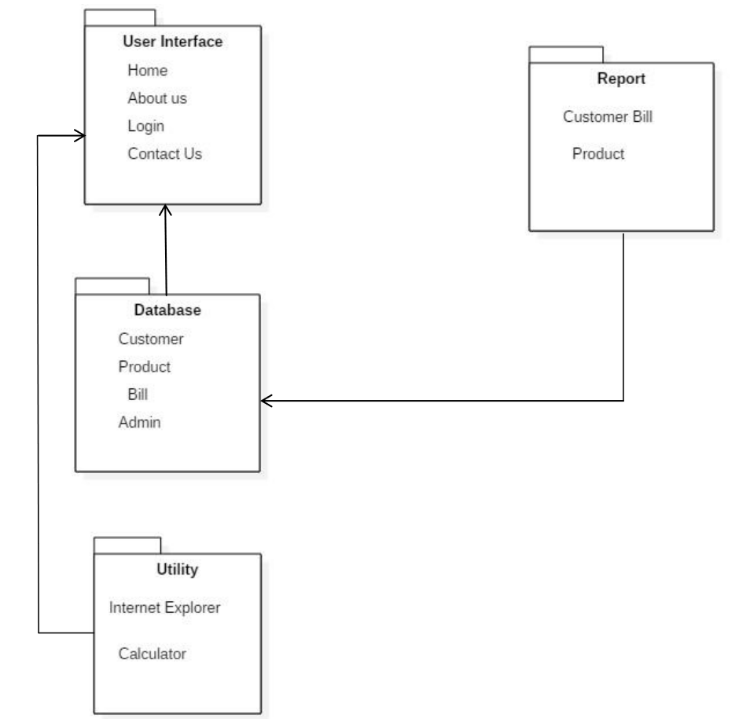

Data Flow Diagram:

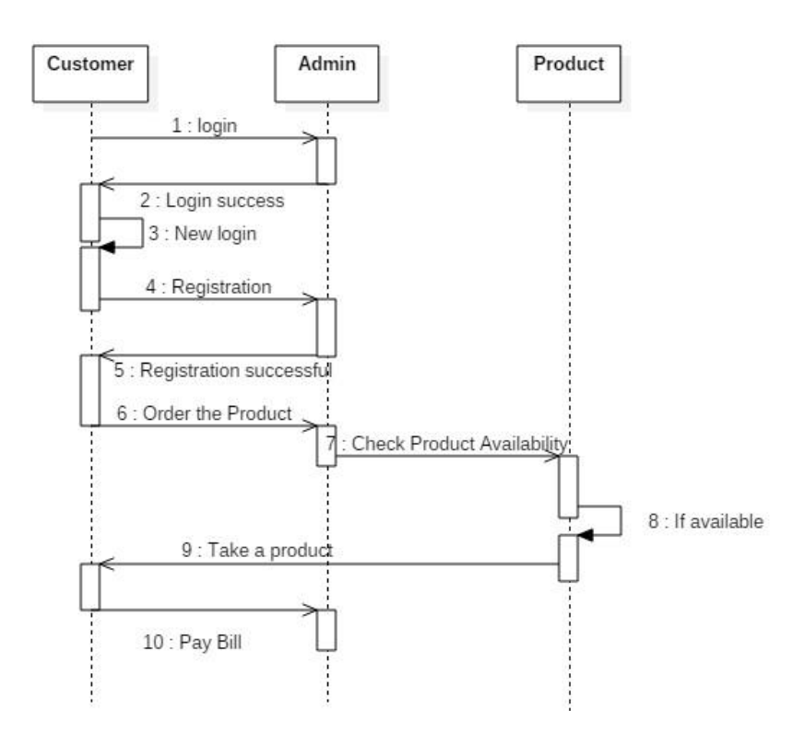

Testing

Testing Plan for BrewTech Coffee Shop Management System

Objective:

The primary objective of the testing plan is to ensure the quality, functionality, and reliability

of the BrewTech Coffee Shop Management System before its deployment. This plan outlines

the testing approach, methodologies, resources, and timelines to achieve this objective

effectively.

Testing Types:

Functional Testing: Ensure that all system functions, including order management, inventory

tracking, customer relationship management, reporting, and user management, work as

expected.

Performance Testing: Evaluate system performance under various load conditions to assess

scalability, responsiveness, and stability.

Usability Testing: Assess the user interface design, navigation, and overall user experience to

ensure ease of use and efficiency.

Security Testing: Identify and address potential security vulnerabilities, such as unauthorized

access, data breaches, and system exploits.

Testing Phases:

Unit Testing: Test individual components/modules of the system in isolation to verify their

correctness and functionality.

Integration Testing: Verify the interactions between different components/modules to ensure

seamless communication and data exchange.

System Testing: Test the entire system as a whole to validate end-to-end functionality and

performance across all modules and features.

User Acceptance Testing (UAT): Involve end-users in testing the system in a real-world

environment to validate usability, functionality, and compliance with user requirements.

Testing Environment:

Development Environment: Conduct testing in a development environment that mirrors the

production environment as closely as possible to ensure consistency and accuracy.

Testing Data: Use realistic testing data, including sample orders, inventory items, customer

records, and transaction data, to simulate real-world scenarios and validate system behavior.

Test Cases: Develop comprehensive test cases covering all functional requirements, edge cases,

error conditions, and performance benchmarks to guide testing activities.

Testing Tools and Techniques:

Utilize automated testing tools, such as PHPUnit for PHP unit testing, Selenium for web UI

testing, and JMeter for performance testing, to streamline testing processes and improve

efficiency.

Conduct manual testing for scenarios that cannot be automated, such as user interface

validation, exploratory testing, and edge case scenarios.

Use load testing tools to simulate concurrent user activity and assess system performance under

heavy load conditions.

Employ security scanning tools, such as OWASP ZAP or Nessus, to identify and mitigate

potential security vulnerabilities in the system.

Testing Resources:

Assign dedicated resources for testing activities, including testers, developers, and domain

experts, to ensure comprehensive coverage and effectiveness.

Provide training and support to testing team members to ensure they are equipped with the

necessary skills and knowledge to execute testing activities effectively.

Testing Schedule:

Develop a detailed testing schedule outlining the sequence of testing activities, milestones, and

timelines for each phase of testing.

Allocate sufficient time for each testing phase, including test preparation, execution, defect

resolution, and retesting, to ensure thorough and rigorous testing.

Reporting and Documentation:

Document the testing strategy, objectives, scope, and approach in a detailed test plan document.

Create detailed test cases with step-by-step instructions, expected results, and actual results for

each test scenario.

Use a defect tracking system to log and track identified issues, including their severity, priority,

status, and resolution.

Generate test reports summarizing test results, including pass/fail status, defect metrics, and

recommendations for improvements.

Review and Validation:

Conduct regular review meetings with stakeholders, development team members, and testing

team members to discuss test results, address issues, and make necessary adjustments.

Validate that all identified defects have been addressed and resolved satisfactorily before

proceeding to system deployment.

**Test Strategy**

Testing Strategy for BrewTech Coffee Shop Management System

Objective:

The testing strategy aims to ensure the quality, functionality, and reliability of the BrewTech

Coffee Shop Management System by outlining the approach, methodologies, and resources for

testing activities.

Testing Types:

Functional Testing: Verify that all system functions, including order management, inventory

tracking, customer relationship management, reporting, and user management, work as

expected.

Non-Functional Testing: Evaluate system attributes such as performance, usability, reliability,

and security to ensure overall system quality.

Regression Testing: Validate that system updates or code changes do not adversely impact

existing functionality or introduce new defects.

Testing Phases:

Unit Testing: Test individual components/modules of the system in isolation to validate their

correctness and functionality.

Integration Testing: Verify the interactions between different components/modules to ensure

seamless communication and data exchange.

System Testing: Test the entire system as a whole to validate end-to-end functionality and

performance across all modules and features.

User Acceptance Testing (UAT): Involve end-users in testing the system in a real-world

environment to validate usability, functionality, and compliance with user requirements.

Testing Approach:

Risk-Based Testing: Prioritize testing efforts based on identified risks, critical functionalities,

and areas of highest impact on system performance and user experience.

Exploratory Testing: Conduct exploratory testing to uncover defects, usability issues, and

unexpected behavior that may not be covered by scripted test cases.

Ad-Hoc Testing: Perform ad-hoc testing to simulate real-world usage scenarios and validate

system behavior in unplanned situations.

Testing Techniques:

Black Box Testing: Validate system functionality from an end-user perspective without

knowledge of internal code structure or implementation details.

White Box Testing: Verify system behavior based on internal code structure and logic, focusing

on code coverage, control flow, and boundary conditions.

User Interface Testing: Evaluate the user interface design, layout, navigation, and

responsiveness across different devices and screen sizes.

Performance Testing: Measure system performance under various load conditions, including

normal usage, peak loads, and stress conditions, to ensure scalability and reliability.

Testing Tools and Resources:

Utilize automated testing tools, such as PHPUnit, Selenium, and JMeter, to streamline testing

processes, improve efficiency, and ensure consistent test coverage.

Assign dedicated testing resources, including testers, developers, and domain experts, to

execute testing activities effectively and efficiently.

Testing Environment:

Establish a testing environment that mirrors the production environment as closely as possible

to ensure accurate simulation of real-world usage scenarios.

Utilize realistic testing data, including sample orders, inventory items, customer records, and

transaction data, to validate system behavior and performance.

Defect Management:

Implement a defect tracking system to log, prioritize, and track identified issues throughout the

testing process.

Classify defects based on severity, priority, and impact on system functionality, and ensure

timely resolution and validation of fixes.

Review and Validation:

Conduct regular review meetings with stakeholders, development team members, and testing

team members to discuss test results, address issues, and make necessary adjustments.

Validate that all identified defects have been addressed and resolved satisfactorily before

proceeding to system deployment.

Documentation and Reporting:

Document the testing strategy, objectives, scope, and approach in a detailed test plan document.

Create comprehensive test cases with step-by-step instructions, expected results, and actual

results for each test scenario.

Generate test reports summarizing test results, including pass/fail status, defect metrics, and

recommendations for improvements.

**Testing Methods:**

Black Box Testing:

Description: Validates system functionality from an end-user perspective without knowledge

of internal code structure.

Test Cases:

Verify that orders can be placed successfully through the user interface.

Test order modification and cancellation functionalities.

Ensure accurate calculation of order totals, including taxes and discounts.

White Box Testing:

Description: Validates system behavior based on internal code structure and logic.

Test Cases:

Verify that data input validation rules are enforced (e.g., mandatory fields, data formats).

Test error handling and exception scenarios (e.g., invalid user inputs, database connection

errors).

Validate control flow and decision points within the system (e.g., branching logic, loops).

User Interface Testing:

Description: Evaluates the user interface design, layout, navigation, and responsiveness.

Test Cases:

Verify that the user interface elements are displayed correctly across different devices and

screen sizes.

Test user interactions such as button clicks, form submissions, and menu navigation.

Ensure accessibility features are implemented and compliant with accessibility standards.

Performance Testing:

Description: Measures system performance under various load conditions to assess scalability

and reliability.

Test Cases:

Conduct load testing to simulate concurrent user activity and assess system response time and

throughput.

Test scalability by gradually increasing the number of concurrent users and monitoring system

performance metrics.

Validate system stability under sustained load over extended periods.

Security Testing:

Description: Identifies and addresses potential security vulnerabilities to safeguard against

unauthorized access and data breaches.

Test Cases:

Verify user authentication and authorization mechanisms to prevent unauthorized access to

sensitive functionalities.

Test input validation and data sanitization to mitigate risks of SQL injection, cross-site

scripting (XSS), and other common security threats.

Conduct penetration testing to identify potential vulnerabilities and weaknesses in the system's

architecture and implementation.

Test Cases:

Order Management:

Test Case 1: Place a new order with valid items and quantities.

Test Case 2: Modify an existing order by adding/removing items or changing quantities.

Test Case 3: Cancel an order and verify that it is removed from the system.

Inventory Management:

Test Case 4: Add a new item to the inventory with all required details.

Test Case 5: Update inventory levels after processing an order and verify accuracy.

Test Case 6: Generate a report of low-stock items and verify accuracy.

Customer Relationship Management (CRM):

Test Case 7: Create a new customer record with all required details.

Test Case 8: Retrieve customer information and verify accuracy.

Test Case 9: Record customer feedback and validate storage in the CRM database.

Reporting and Analytics:

Test Case 10: Generate a sales report for a specific time period and verify accuracy.

Test Case 11: Analyze sales trends and compare against historical data.

Test Case 12: Export a report in a specified format (e.g., PDF, CSV) and verify integrity.

User Management:

Test Case 13: Create a new user account with valid credentials and permissions.

Test Case 14: Update user profile information and verify changes.

Test Case 15: Disable a user account and verify that access is revoked.

**Screen shot**

**Limitation and future Enhancement**

Limitations of BrewTech Coffee Shop Management System:

Scalability: The system may face scalability issues as the number of transactions, customers,

and products increases over time. It may struggle to handle a high volume of concurrent users

during peak hours.

Limited Integration: The system may have limited integration capabilities with third-party

platforms or services, such as accounting software, payment gateways, or marketing tools,

which could restrict its functionality and interoperability.

User Interface Complexity: The user interface may be complex or overwhelming for

inexperienced users, leading to potential usability issues and a steep learning curve for new

staff members.

Security Concerns: The system may have potential security vulnerabilities, such as data

breaches, unauthorized access, or information leakage, if robust security measures are not

implemented and maintained.

Performance Issues: The system may experience performance degradation or slowdowns under

heavy load conditions, impacting user experience and system responsiveness.

**Conclusion**

In conclusion, the development and implementation of the BrewTech Coffee Shop Management System represent a significant milestone in optimizing and modernizing BrewTech's operations. This comprehensive system addresses various aspects of coffee shop management, including order processing, inventory management, customer relationship management, reporting, and user management. Throughout the project lifecycle, several key components were meticulously designed, developed, and tested to ensure functionality, reliability, and usability.

The project began with a thorough analysis of BrewTech's requirements, challenges, and objectives, laying the foundation for system design and development. Leveraging technologies such as HTML, PHP, JavaScript, and CSS, the system was architecture to provide a seamless and intuitive user experience while incorporating robust backend functionality to support BrewTech's operations.

Through iterative development cycles and rigorous testing methodologies, the Coffee Shop Management System underwent extensive validation to ensure it met stakeholder expectations and quality standards. Functional testing verified the correctness and completeness of system features, while performance testing assessed scalability, responsiveness, and stability under varying load conditions. Usability testing ensured an intuitive and user-friendly interface, while security testing addressed potential vulnerabilities to safeguard sensitive data and transactions.

Upon successful completion of testing and validation phases, the BrewTech Coffee Shop Management System is poised to revolutionize BrewTech's operations, streamlining processes, enhancing efficiency, and improving customer experiences. With features such as automated order processing, real-time inventory tracking, personalized customer engagement, and insightful reporting and analytics, BrewTech can now operate more effectively, make data-driven decisions, and drive business growth.

Looking ahead, the project's conclusion marks the beginning of a new chapter for BrewTech, one characterized by innovation, agility, and continuous improvement. As BrewTech evolves and expands its business, the Coffee Shop Management System will evolve alongside it, incorporating future enhancements, addressing emerging challenges, and staying ahead of industry trends. Through ongoing collaboration, feedback, and optimization efforts, BrewTech will continue to leverage technology to deliver exceptional coffee experiences and delight customers for years to come.

ref